**NATURAL DISASTERS INTENSITY ANALYSIS AND CLASSIFICATION USING ARTIFICIAL INTELLIGENCE**

Project Design Phase-II

Data Flow Diagram

|  |  |
| --- | --- |
| Date | 15 October 2022 |
| Team ID | PNT2022TMID20222 |
| Project Name | Project - Natural disaster intensity analysis and  Classification using AI |
| Maximum Marks | 4 Marks |

# Data Flow Diagrams:

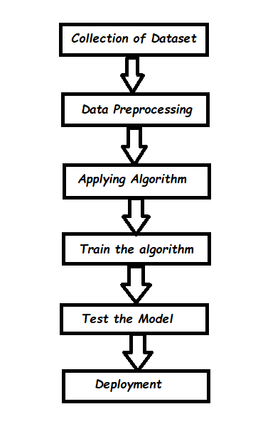

A Data Flow Diagram (DFD) is a traditional visual representation of the information flows within a system. A neat and clear DFD can depict the right amount of the system requirement graphically. It shows how data enters and leaves the system, what changes the information, and where data is stored.

Example : DFD Level 0 (Industry Standard)

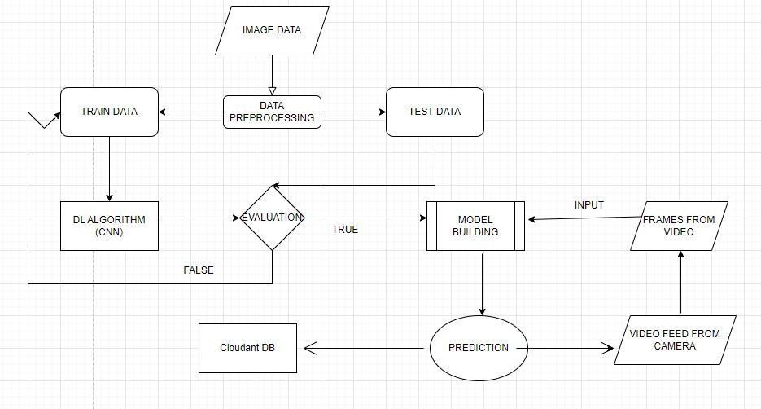

# User Journey

|  |  |  |  |  |  |  |
| --- | --- | --- | --- | --- | --- | --- |
| **User Type** | **Functional Requirement**  **(Epic)** | **User Story Number** | **User Story / Task** | **Acceptance criteria** | **Priority** | **Release** |
| Customer (Mobile user) | Registration | USN-1 | As a user, I can register for the application by entering my email, password, and confirming my password. | I can access my account / dashboard | High | Sprint-1 |
|  |  | USN-2 | As a user, I will receive confirmation email once I have registered for the application | I can receive confirmation email & click confirm | High | Sprint-1 |
|  |  | USN-3 | As a user, I can register for the application through Facebook | I can register & access the dashboard with Facebook  Login | Low | Sprint-2 |
|  |  | USN-4 | As a user, I can register for the application through Gmail | I can register & access the dashboard with Gmail Login | Medium | Sprint-1 |
|  | Login | USN-5 | As a user, I can log into the application by entering email & password | I can login & access my account with my registered credentials | High | Sprint-1 |
|  | Dashboard | USN-6 | As a user, I can access the services and information provided in the dashboard | I can upload the images, I can view the result, I can edit my profile and I can view my history | High | Sprint-1 |
| Customer (Web user) | Login | USN-7 | As a user, I can log into the web application and access the dashboard | I can login with the same registered credentials and access my account  through web application | High | Sprint-1 |

|  |  |  |  |  |  |  |
| --- | --- | --- | --- | --- | --- | --- |
| **User Type** | **Functional**  **Requirement (Epic)** | **User Story Number** | **User Story / Task** | **Acceptance criteria** | **Priority** | **Release** |
| Customer Care Executive | Help Desk | USN-8 | As a user, I can get the guidance from the customer care | I can get help from the  customer care for carrying out my tasks | High | Sprint-2 |
| Administrator | Management | USN-9 | As an administrator, I can collect new datasets and keep the model trained | I can collect and train the  model with new dataset frequently | High | Sprint-2 |
|  |  | USN-10 | As an administrator, I can update other features of the application | I can update and tune the  features of application if needed | Medium | Sprint-1 |
|  |  | USN-11 | As an administrator, I can maintain the information about the user | I can maintain information  like user type and other such information | Medium | Sprint-1 |
|  |  | USN-12 | As an administrator, I can maintain third-party services | I can support and maintain any third-party services | Low | Sprint-2 |